Practical
Issues Detected by Bandit
Copilot finding | Bandit detected it? | Bandit ID and line | Explanation | Secure remediation
Importing pickle | Yes | B403, line 2 | Bandit flags the pickle import because it can enable unsafe deserialization when used with untrusted data. | Avoid pickle for untrusted data; use JSON or another safe, validated format.
Importing subprocess | Yes | B404, line 3 | Bandit flags the module because unsafe subprocess usage can lead to command execution vulnerabilities. The import itself does not prove exploitation. | Prefer avoiding subprocesses; otherwise use fixed commands, argument lists, validation, and no shell.
Hardcoded password | Yes | B105, line 5 | admin123 is embedded directly in source code, allowing anyone with source access to obtain it. | Use a secret manager or protected environment variable and rotate the exposed password.
Weak MD5 password hashing | Yes | B324, line 10 | MD5 is unsuitable for password hashing because it is fast and vulnerable to brute-force attacks. | Use Argon2id, scrypt, or bcrypt with a unique salt.
Shell command injection | Yes | B602, line 14 | User input is passed to subprocess.call with shell=True, allowing shell syntax to be interpreted. | Remove shell=True, use a fixed executable with an argument list, and validate inputs.
Unsafe pickle deserialization | Yes | B301, line 18 | pickle.loads can execute attacker-controlled code during deserialization. | Never deserialize untrusted pickle data; use a safe format such as JSON with validation.
SQL injection | Yes | B608, line 22 | username is concatenated directly into the SQL query, allowing query manipulation. Bandit reported low confidence for this finding. | Use parameterized queries or prepared statements.

Issues Identified by Copilot but Not Detected by Bandit
Copilot finding | Bandit detected it? | Bandit ID and line | Explanation | Secure remediation
Hardcoded API key | No | No Bandit finding or reported line | API_KEY = "12345-SECRET-KEY" appears in source at app.py line 6. Bandit’s B105 finding covered only the password on line 5, not this API key. | Remove the key from source, store it in a secret manager or protected environment variable, and rotate it.
Debug mode enabled | No | No Bandit finding or reported line | DEBUG = True appears at app.py line 21. If used by the surrounding application, production debug behavior could expose sensitive error details or debugging functionality. This file alone does not show how the flag is used. | Disable debug mode in production and make it controlled by a secure deployment configuration.

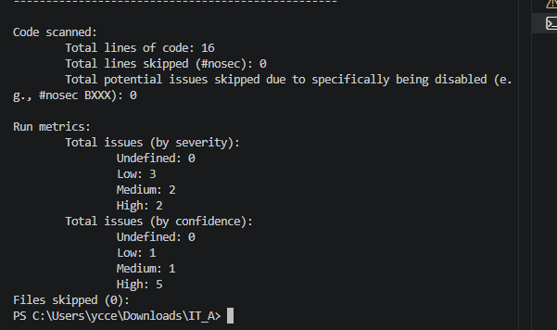
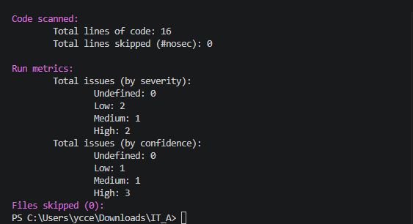
Fix 1 :-
Original issue: B301/B403
Original lines: 2 and 18
Fix: Replaced unsafe pickle serialization/deserialization
with JSON
Verification: Re-ran Bandit
Result: B301/B403 no longer reported

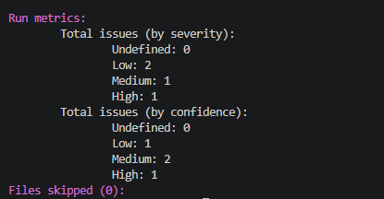
Fix 2 :-
Original issue: B404/B602
Original lines: 3 and 14
Fix: Removed subprocess with shell=True and
replaced it with non-shell process execution
Verification: Re-ran Bandit
Result: B404/B602 no longer reported; Bandit then reported
B606 for the remaining process-execution pattern

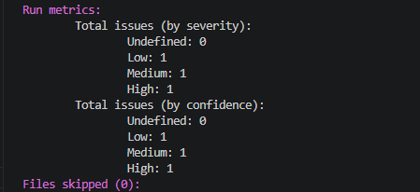
Fix 3 :-
Original issue: B606
Original line: 16
Fix: Restricted process execution so user input cannot directly
determine an arbitrary operating-system command
Verification: Re-ran Bandit
Result: B606 no longer reported
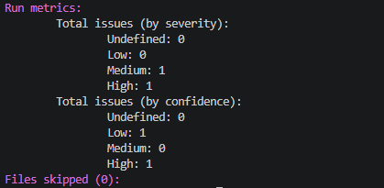
Fix 4 :-
Original issue: B105
Original line: 6
Fix: Removed the hardcoded password and changed the
application to obtain the password from an environment variable
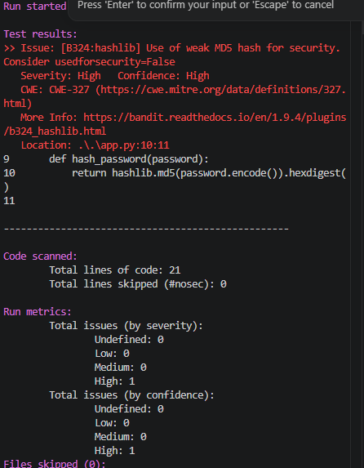
Verification: Re-ran Bandit
Result: B105 no longer reported

Fix 5 :-
Original issue: B608
Original line: 27
Fix: Replaced the SQL query's string concatenation with a
parameterized query to prevent SQL injection.
Verification: Re-ran Bandit
Result: B608 no longer reported.

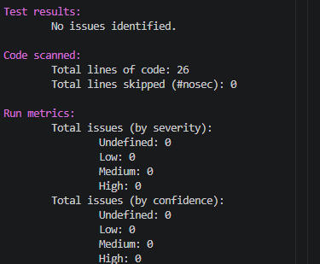
Fix 6 :-
Original issue: Debug mode enabled (DEBUG = True)
Original line: 21
Fix: Changed the hardcoded debug setting to an environment-
controlled configuration with debug disabled by default.
Verification: Re-ran Bandit
Result: No Bandit finding was generated for the debug configuration;
the issue was remediated manually

Fix 7 :-
Original issue: B324
Original line: 10
Fix: Replaced the insecure MD5 password hashing algorithm with
PBKDF2-HMAC-SHA256 using a unique random salt and a high iteration count.
Verification: Re-ran Bandit
Result: B324 no longer reported.

